* Inheritance
* Interface
* Keyword
  + super

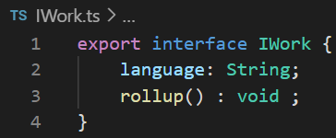

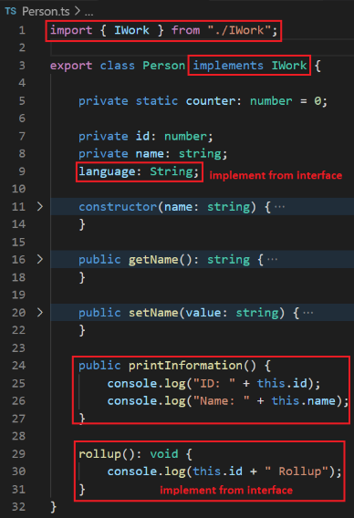

* **Reference**

<https://www.javatpoint.com/typescript-inheritance>

<https://www.javatpoint.com/typescript-interface>

<https://www.javatpoint.com/typescript-function-overloading>